vDry skin can flake, itch, crack, and even bleed. These tips from board-certified dermatologists can help you heal excessively dry skin at home:

Limit baths and showers to five to ten minutes, using warm water. A short shower or bath in warm water can add moisture to your skin. Close your bathroom door while showering to help hydrate your skin more. To dry off after bathing, gently pat your skin with a clean, dry towel. Rubbing your skin dry can irritate extremely dry skin.
Wash your skin with a gentle cleanser. Dry skin is damaged skin. Apply enough cleanser to remove dirt and oil but avoid using so much that you see a thick lather. Use the cleanser only where you need it, such as your armpits or groin area.

Shave at the end of your shower or bath. The water makes your skin and hair softer and less likely to get irritated by shaving. When you finish your shower or bath, gently pat your skin dry and immediately apply your fragrance-free moisturizer.

Apply moisturizer several times a day. Moisturizer plays a key role in healing dry skin. Be sure to apply your moisturizer when your skin is still damp after taking a shower or bath, after washing your hands, and when your skin feels dry. Take time to gently massage the moisturizer into your skin. To keep dry lips hydrated, apply lip balm or petroleum jelly.

Moisturizer relieves dry skin

To help heal overly dry skin, apply a cream or ointment when your skin feels dry and take time to gently massage the moisturizer into your skin.

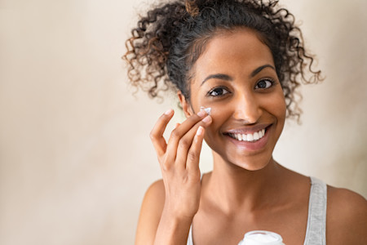

Protect your skin from the sun. Apply a broad-spectrum, water-resistant sunscreen with an SPF of 30 or higher, along with seeking shade and wearing sun-protective clothing. Avoid tanning — indoors and out.

Use a humidifier. Dry skin needs moisture. You can boost the humidity level in your home with a humidifier. Some home heating systems have a humidifier. You can also use a portable humidifier. If you use a portable humidifier, place it in your bedroom and run it while you sleep. Clean your humidifier regularly to prevent mold.

Wear gloves. Our hands are often the first place we notice dry skin. If you wash dishes, garden, or immerse your hands in water throughout the day, you can worsen your already dry skin. Wearing gloves that keep your dry skin from getting wet and protected from cold, dry air (like in the winter) can help your skin heal.

Wear loose-fitting cotton clothes. Tight clothes, such as leggings and body-hugging jeans, rub against your skin, which can worsen dry skin. Wearing clothing made of wool or polyester against your skin can also irritate dry, sensitive skin. To prevent irritating your skin, wear loose-fitting cotton clothing and a cotton or silk layer under clothes made of rough fabrics.

Tip
To relieve dry hands, carry a non-greasy hand cream with you and apply it after each hand washing.
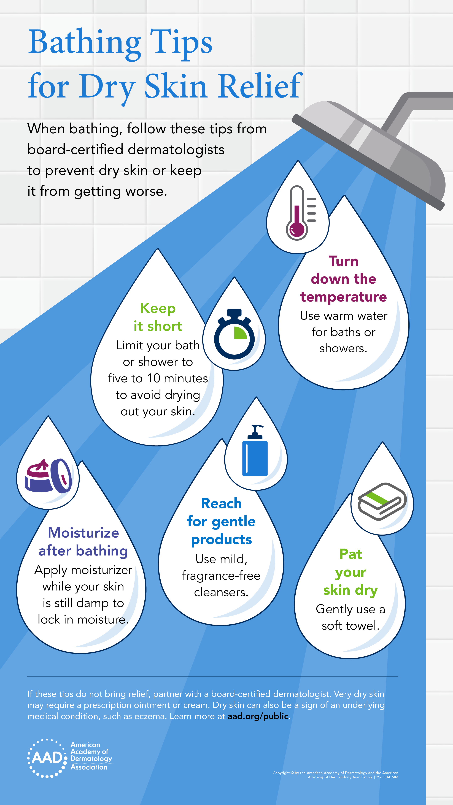Baths and showers can worsen dry skin. You can prevent baths and showers from worsening dry skin by following these dermatologists' tips. Click the image above to download a PDF.

What skin care products are best for dry skin?
It’s easy to feel overwhelmed when looking for the best products to relieve your dry skin. With so many products on the market and numerous recommendations coming from advertisements and social media, it can be hard to tell what you should use. The truth is you may already have the product(s) you need at home.
Here’s what dermatologists recommend you look for:

Gentle, fragrance-free skin care products. Some skin care products, such as deodorant soaps, are too harsh for dry, sensitive skin. Dermatologists recommend using products labeled "fragrance-free."
If you see the word "unscented," the product can contain chemicals that neutralize or hide the odors of other ingredients. These chemicals can irritate dry, sensitive skin.

Ointment or cream (rather than lotion). Ointments and creams add more moisture to skin and are more effective than lotions. Look for a cream or ointment that contains one or more of the following ingredients:

  - Jojoba oil
  - Dimethicone
  - Glycerin
  - Hyaluronic acid
  - Lactic acid
  - Lanolin
  - Mineral oil
  - Petrolatum
  - Shea butter

Lip balm or petroleum jelly. When choosing a lip balm, pick one that feels good on your lips. If your lips sting or tingle after you apply the lip balm, switch to one that does not cause this reaction.

